**Kubernetes GitOps**

1. Authentication

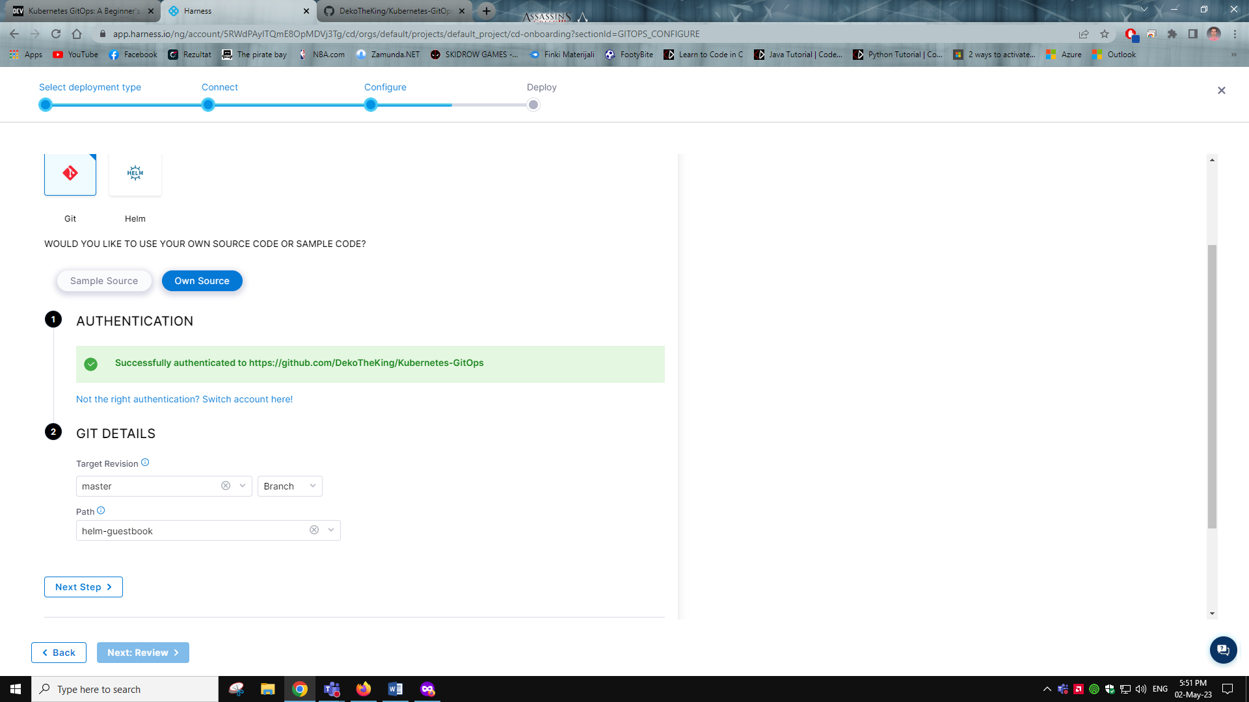

1. Connecting to cluster with Harness hosted

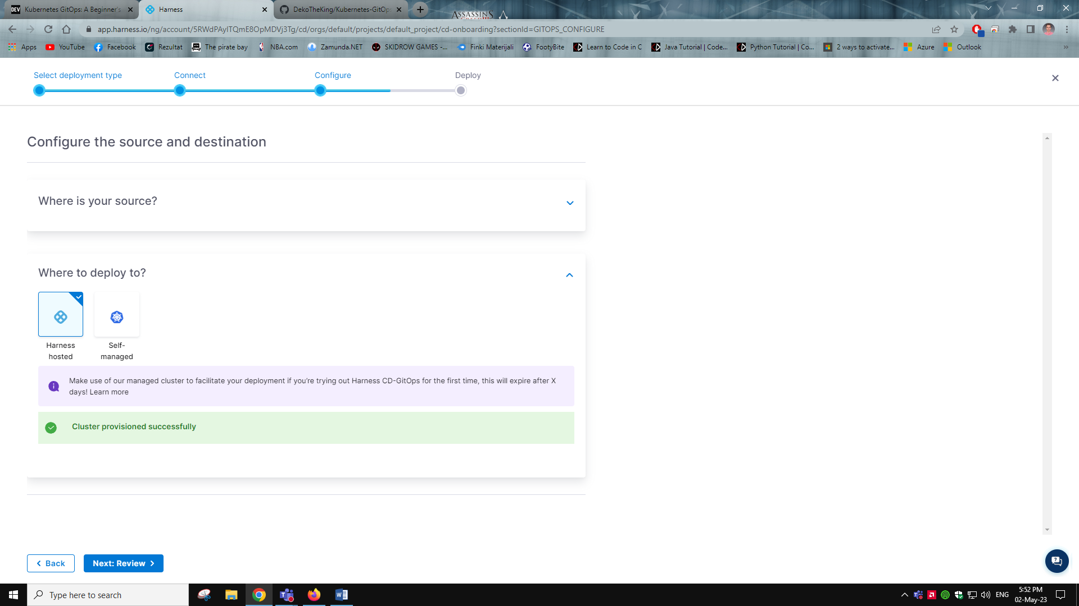

1. The app is healthy and running

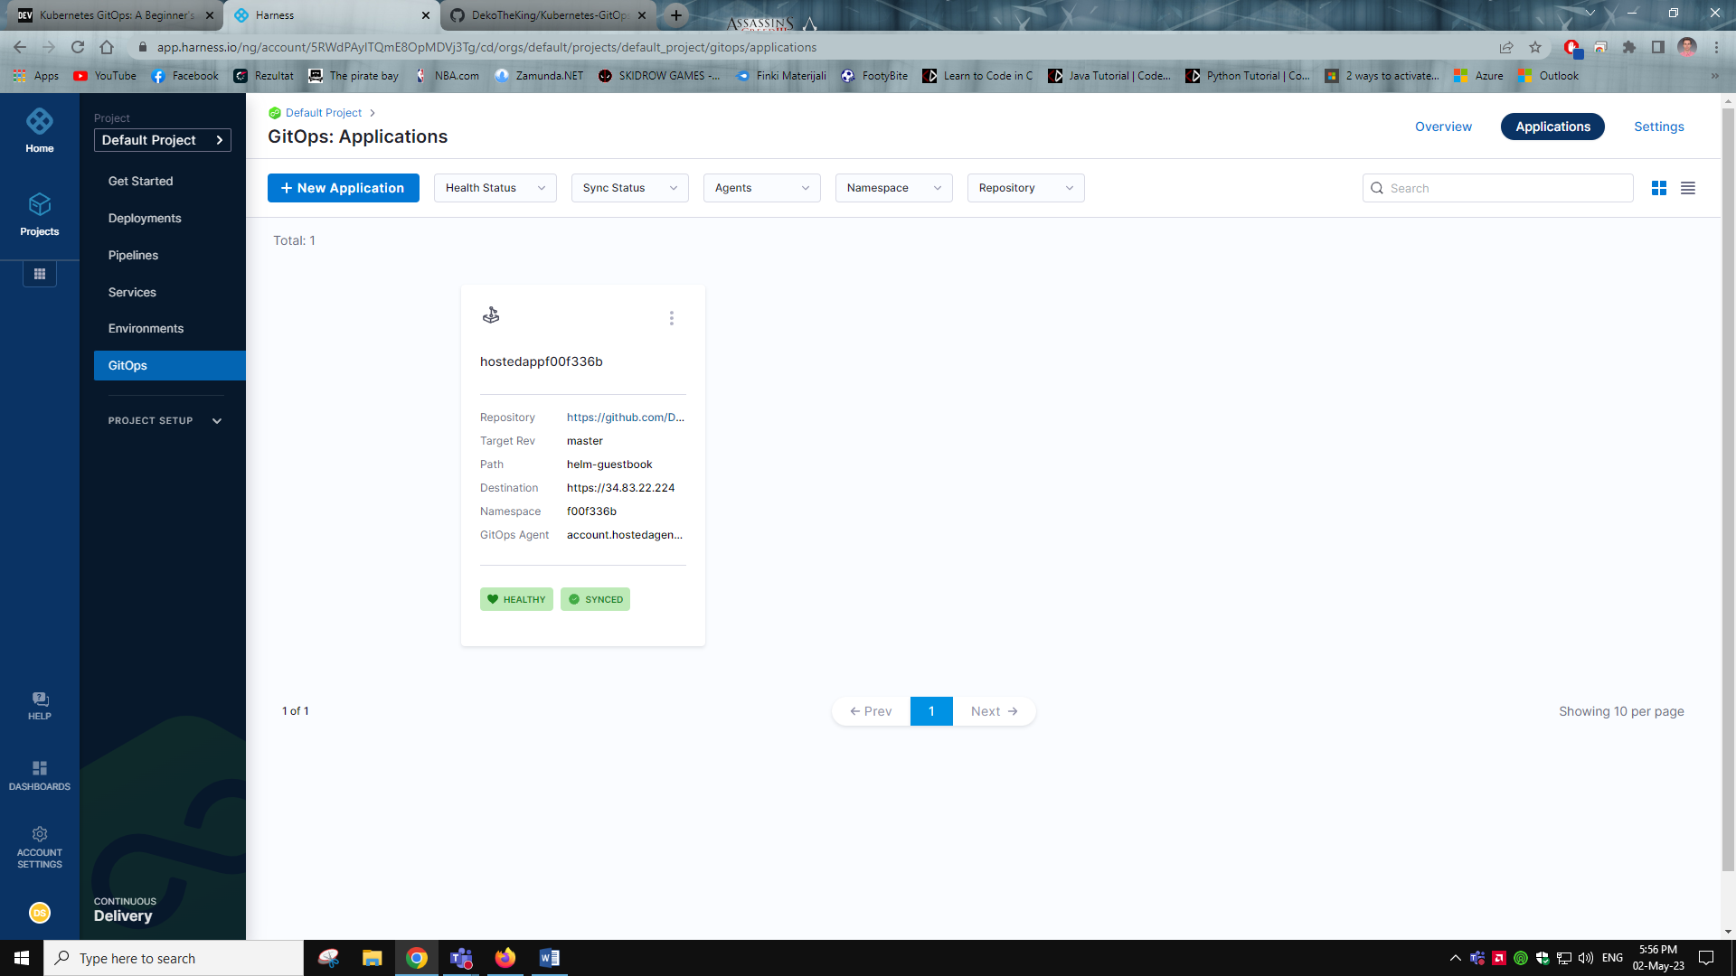

1. Changing the replica count from 4 to 5 and syncing changes

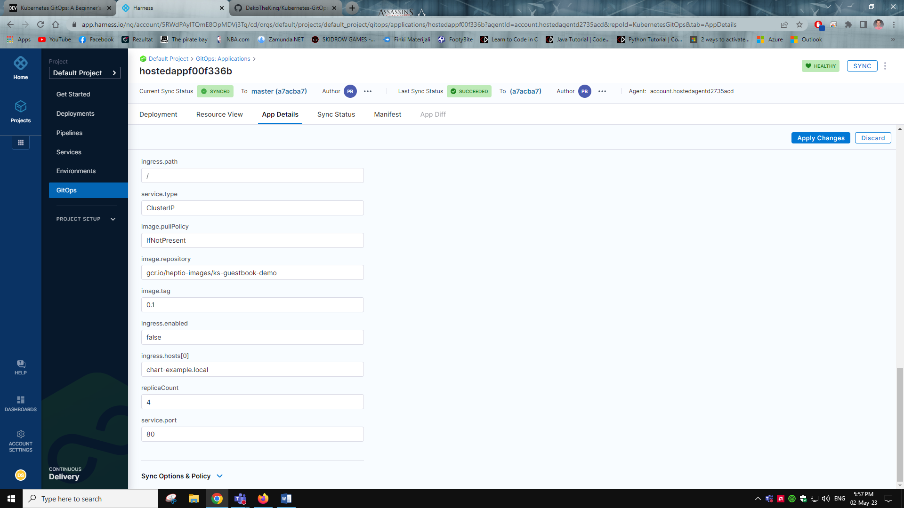

1. Here we see what changes we had made with the last sync

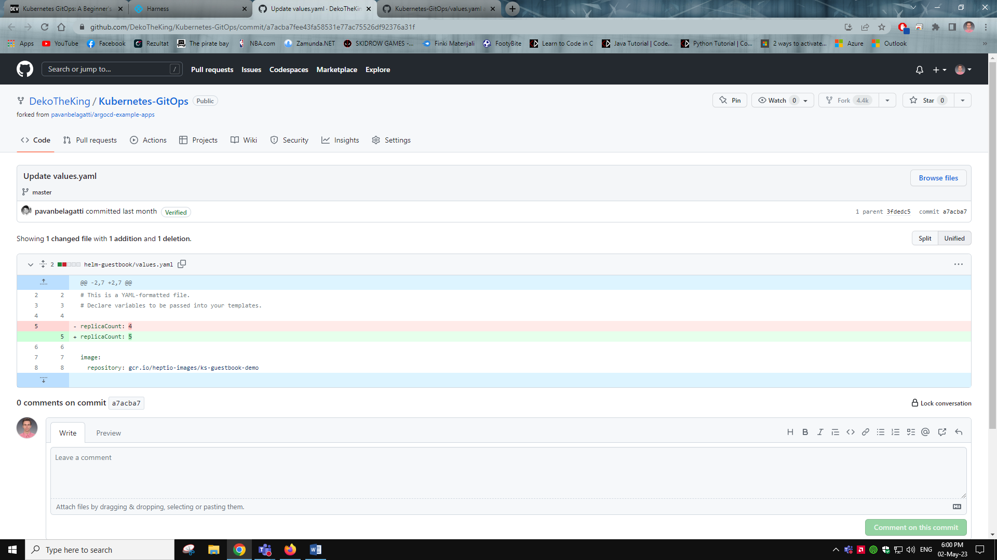

1. A view of the resource after applying the changes all working, healthy and in sync

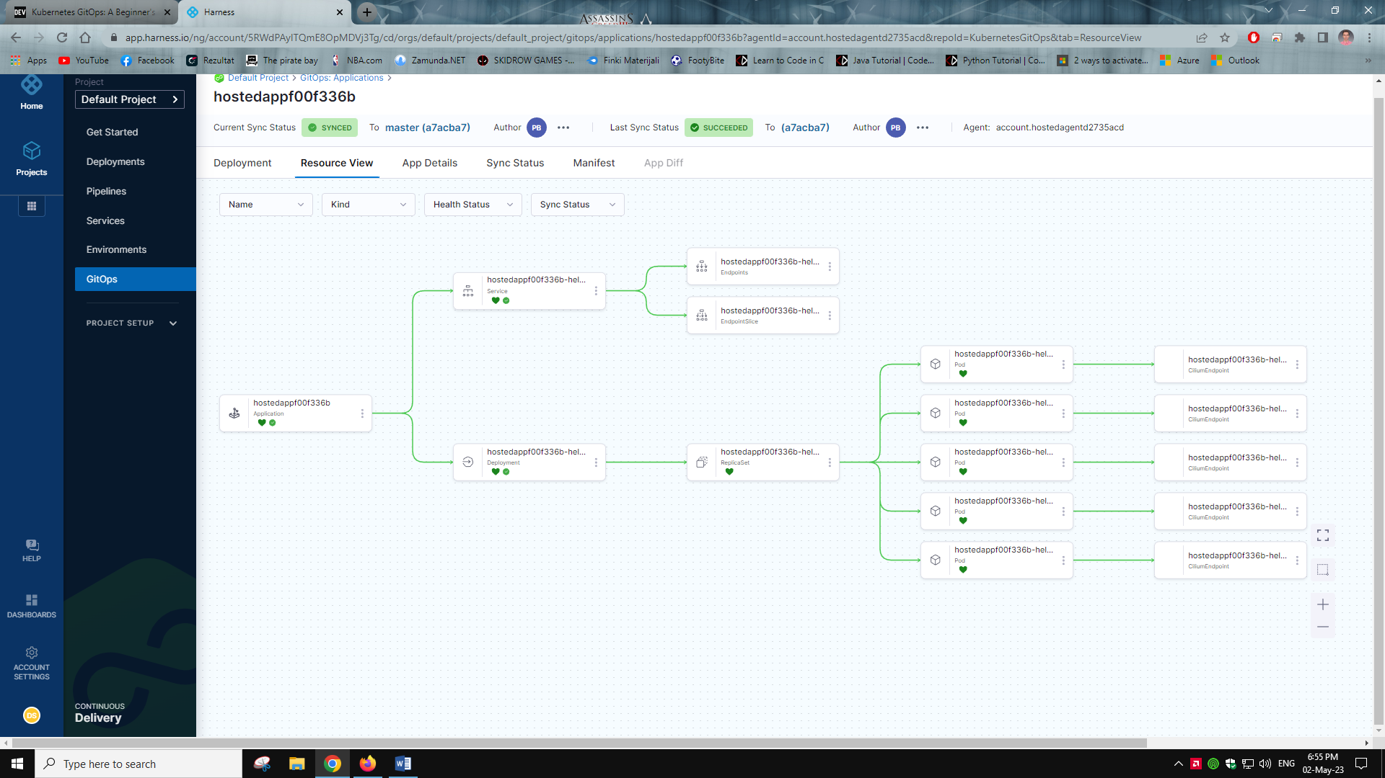

<https://dev.to/pavanbelagatti/kubernetes-gitops-a-beginners-guide-with-a-hands-on-tutorial-56de>